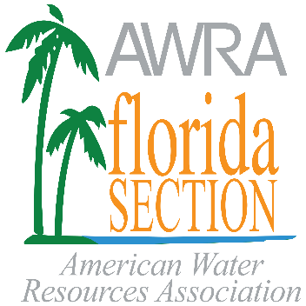
Florida Section, American Water Resources Association, Inc.
The Rosanne Clementi Education Program
J.B. Butler Science Grant
The Florida Section of the American Water Resources Association (AWRA Florida) is a multidisciplinary professional organization concerned with the conservation, development, management and utilization of fresh and estuarine waters and related resources together with their environmental aspects. The intent of the J.B. Butler Science Grant is to promote education about water resources by funding projects focused on the science of water resources. AWRA Florida offers grants up to $1,000 to science teachers and other environmental education programs focusing on students in grades pre-K through 12. Typically, the grant is awarded to teacher(s) who will utilize the award in renewable educational modules or multi-use supplies. One-time uses like transportation are typically not funded.
About the J.B. Butler Science Grant
AWRA Florida established the J.B. Butler Science Grant in 1992 in honor of our colleague and former AWRA Florida President, J.B. Butler. This grant is intended to provide educational materials to Florida science teachers and other environmental education programs focusing on students in grades pre-K through 12. Grant money is awarded to educators to promote water resources educational units.
The application deadline for this grant is April 15, 2021 with the awards being announced following the August 2021 AWRA Florida Board of Director’s meeting.

Application Requirements and Instructions:
APPLICATIONS MUST BE SUBMITTED ELECTRONICALLY AS ONE PDF FILE. (The Principal or Executive Director signature page can be emailed to us separately at awra@awraflorida.org)
- Complete the application.
- Application packages must be submitted to AWRA Florida no later than April 15, 2021.
- Outline your proposed grant use including a proposed budget. Be concise, but thorough. You may include attachments.
- A signature from your Principal or Executive Director is required.
- Agree to provide a descriptive letter report of the project to AWRA Florida by the end of the next school term or educational program period.
- Application packages must be combined into a single PDF file, named with your last name, the award name and year (e.g. “ApplicantLastName_Butler_2021.pdf”).
- Submit application package onine at https://www.awraflorida.org/event-3858692. Click the “Register” button to begin the application submittal process.
If you have any questions or do not receive an appliation receipt confirmation email, call or email Gordon Brown at (352) 246-1865 or gbsailorny@msn.com.

2021 J.B. Butler Science Grant Application

Name:

Organization Name:

Organization Address: City State Zip

Phone: ( )

Email Address:

Grade Level (please circle at least one): Pre-School Elementary Middle High School

Grades taught: Primary discipline taught:

Number of years teaching science: Number of science classes taught per day:

Estimated number of students to benefit from grant:

Grant Funding Request: $ Total Funding Required $

Are matching funds available? Yes No If yes, source? Amount?

Have you ever been awarded a J.B. Butler Science Grant? If yes, when?

How did you hear about the J.B. Butler Science Grant? Specifically, from whom? With which organization?

Proposed grant use including a proposed budget. Be concise, but thorough. Please include whether the materials/equipment/items will be reused and how many students/participants will be benefited from this grant. You may respond on this form and/or use additional sheets.

Applicant Signature: Date

TO BE COMPLETED BY PRINCIPAL OR EXECUTIVE DIRECTOR

Name: Title

Organization Name:

Phone: ( )
Email Address:

SIGNATURE OF PRINCIPAL OR EXECUTIVE DIRECTOR REQUIRED
I support the applicant’s grant application. To the best of my knowledge, I verify that the applicant’s information provided above is accurate.

Principal Signature: Date:

